Real-Time Bridge Monitoring

User Guide

Version 2.0
Revision History

Date | Version | Description | Author
2013-12-12 | 1.1 | First Setup of the document | Andrea Bottoli
2014-01-13 | 1.2 | 1. Introduction | Miraldi Fifo
2014-01-13 | 1.3 | 1.5. Definitions - deleted  1.5. References - added  3.1. External User  3.3. Engineer | Dzana Kujan
2014-01-14 | 1.4 | 2 – deleted  2.2. Operator  2.3. Engineer  2.4. Administrator | Dzana Kujan

Table Of Contents
1.Introduction 4
1.1Purpose of this document 4
1.2Document organization 4
1.3Intended Audience 4
1.4Scope 4
1.5References 4
2.Usage of the product 5
2.1External User 5
2.2Operator 8
2.3Engineer 12
2.4Administrator 13

Introduction

Purpose of this document
The purpose of this document is to provide a first guide on how the user can use our product. The document also highlights the fuctionalities of the product.

Document organization
The document is organized as follows:
- Section 1, Introduction, describes contents of this guide, used documentation during developing process etc.
- Section 2, First Setup, describes the first steps to perform in order to use in the correct way the product.
- Section 3, Usage of the product, describes how to use the web site of our product.

Intended Audience
The intended audience is:
- The customers
- Anyone that wants to use this product

Scope
The document addresses only the functionalities of the product and provides a guide that can help the user to use the product. It does not address the guide of installation. For more details on that consult the installation guide.

References
- Project site
  - www.fer.unizg.hr/rasip/dsd/projects/real-time_bridge_monitoring
- Documentation
  - http://www.fer.unizg.hr/rasip/dsd/projects/real-time_bridge_monitoring/documents
- Application site
  - 161.53.67.134/BridgeMonitoring/

Usage of the product

External User

2.1.1 Home page
When entering the site for the first time as an external user, the initial page that is opened is the home page, which can be seen on the picture below. Here, a short description of the product is given and a presentation of all team members that worked on its implementation, as well as contact and license information.
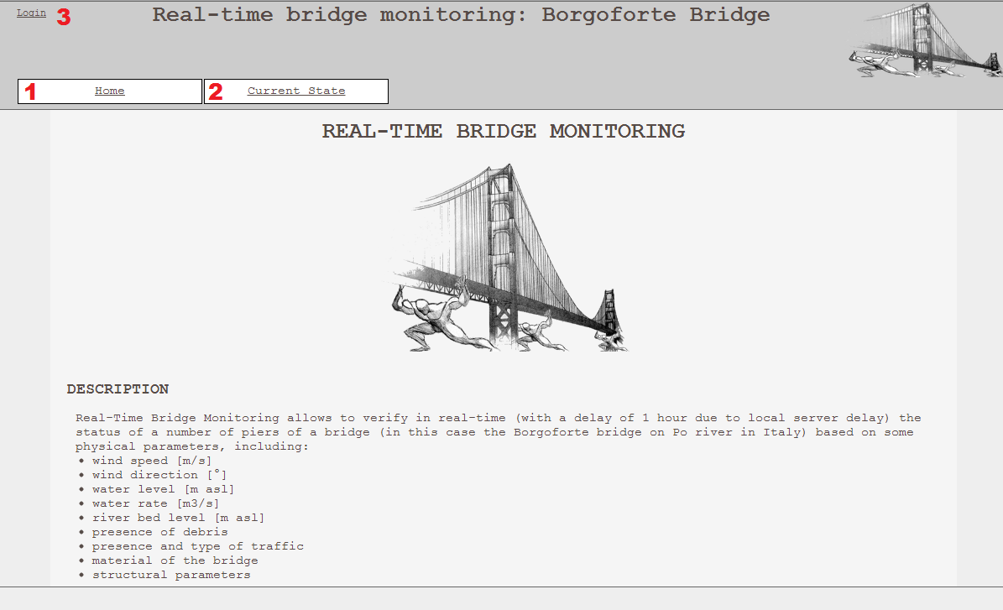
From here, it is possible to click on:
- Home
This action will leave you on the home page
- Current State (2.1.2)
This action will take you to the “Current State” page, where you can view the current status of the bridge
- Log-in (2.1.3)
This action will take you to the “Log-in” page where you can log into the site with a valid user-name and password

2.1.2. View current bridge status
When clicking on the current state button (2), the following page is shown:
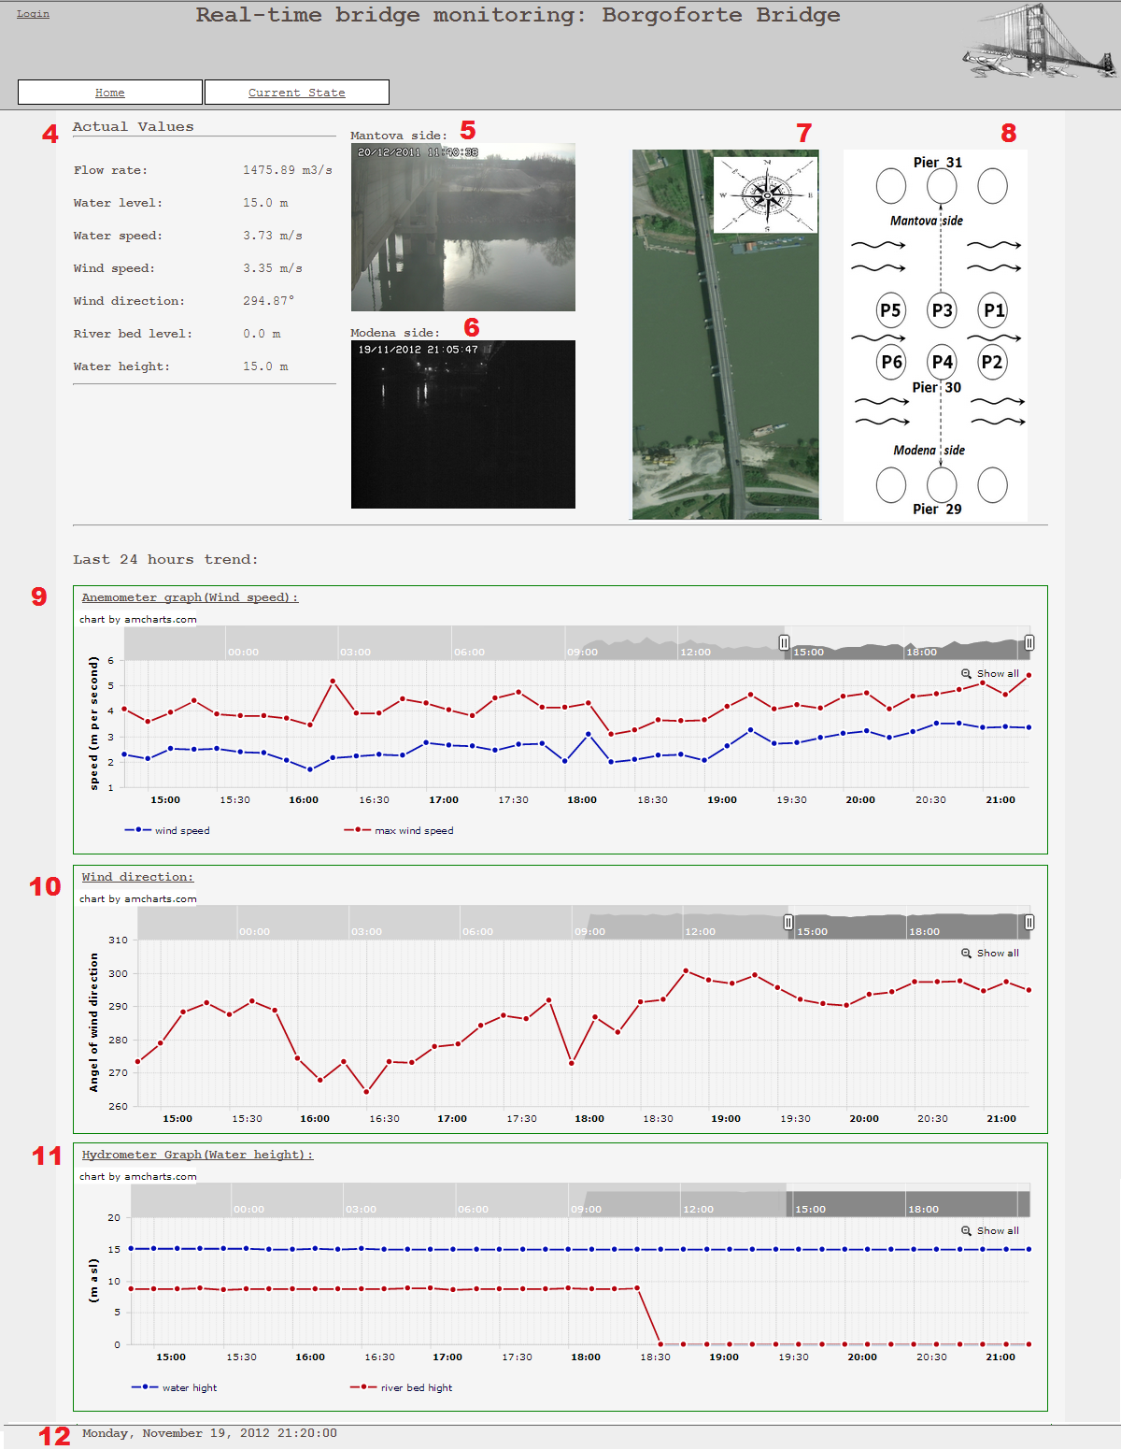

The elements on this page represent the following:
- The latest values that are read from the sensors
- The latest picture taken from the camera on the Mantova side of the bridge
- The latest picture taken from the camera on the Modena side of the bridge
- A picture from Google maps of the Borgoforte bridge
- A picture representing the structure of the bridge
- Graph representing the last 24 hours wind speed and max wind speed, detected by the anemometer. On this graph, ten minute data is displayed, and the unit for the wind speed is mps (meter per second)
- Graph representing the last 24 hours wind direction. On this graph, ten minute data is displayed and the wind direction is presented in angles
- Graph representing the last 24 hours water height and river bed height, detected by the hydrometer. On this graph, ten minute data is displayed
- Label which marks the date and time of the last parsed data from the database

2.1.3. Log in as a registered user
When clicking on the log-in button (3), the following page is shown:
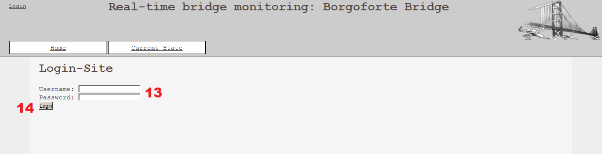
The elements on this page represent the following:
- User-name and Password fields
- Log-in button. If the user-name and password are correct, a click on this button will redirect the user to the appropriate page for the user that is chosen

Operator

2.2.1. Home page
When entering the site for the first time as the operator, the initial page that is opened is the home page for the operator, which can be seen on the picture below. The information that is written on the home page for the operator is the same as the information for the external user. The difference is that the operator has additional tabs.
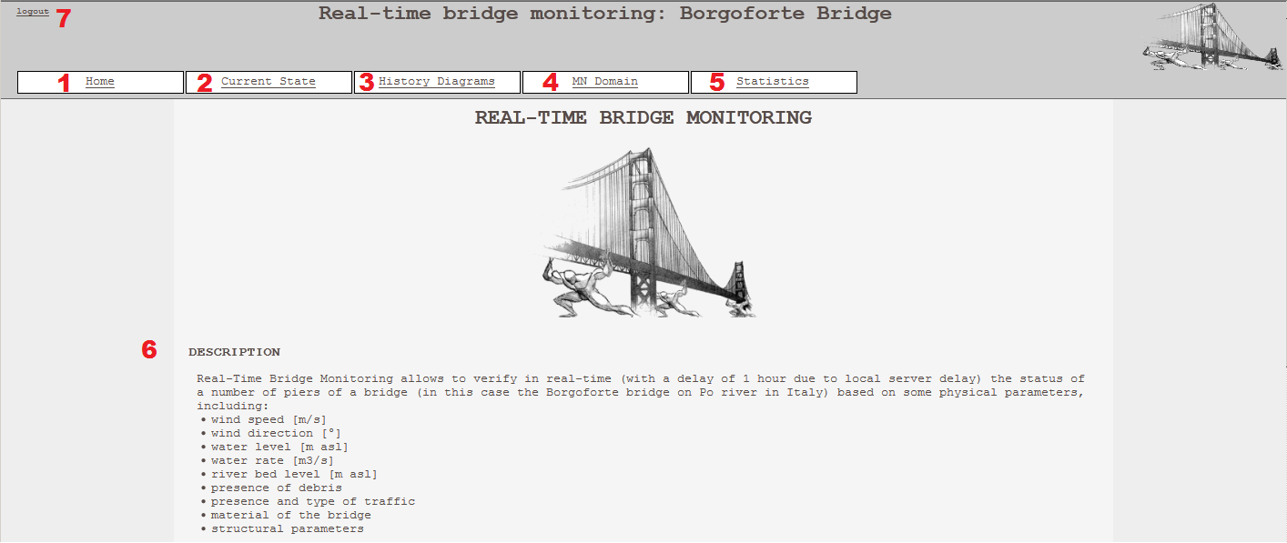
From the home page, the operator is able to click on:
- Home
This action will leave you on the home page
- Current State (2.2.2)
This action will take you to the “Current State” page, where you can view the current status of the bridge
- History diagrams (2.2.3)
This action will take you to the “History View” page, where you can view historical data of the bridge
- MN Domain (2.2.4)
This action will take you to the “MN Domain View” where the latest MN domain is presented
- Statistics (2.2.5)
This action will take you to the statistics page, which contains interesting statistical data about the product
- The description of the product.
- Log-out (2.2.6)
This action will log you out instantly

2.2.2. View current bridge status
The “Current State” page is the same for both the operator and external user, and is explained in section 3.1., External User.

2.2.3. View history diagrams
When clicking on the “History Diagrams” tab (3), the following page is opened.
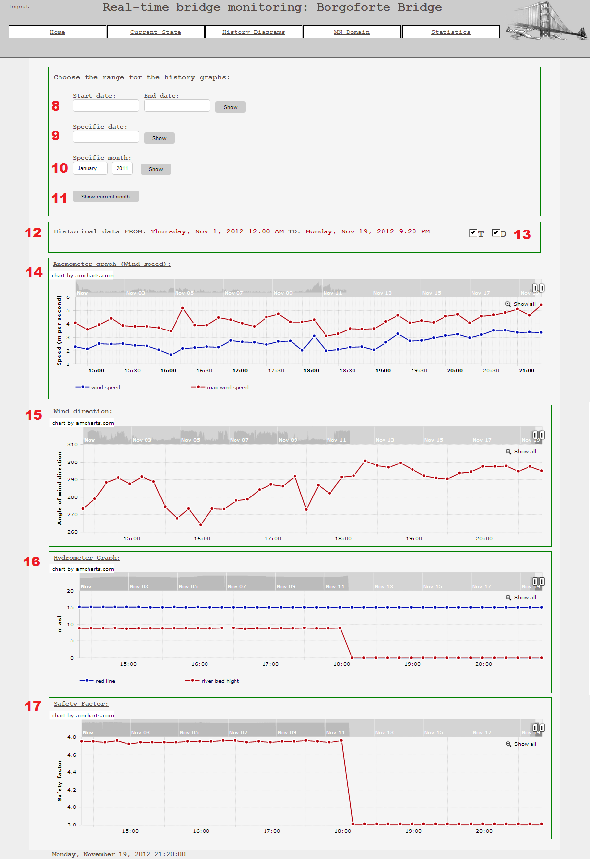
The elements on this page represent the following:
- The user can choose a range between two dates for which he wishes to see the history data. Enter a start date and an end date and click on “Show”.
- The user can choose a specific date for which he wishes to see the history data. The data will be ten minutes data for that day. Enter the specific date and click on “Show”.
- The user can choose a specific month for which he wishes to see the history data. The data will be ten minutes data for that month. Enter the month and the year and click on “Show”.
- The user can choose to view historical data for the current month by clicking on “View current month”.
- This is a label telling the range of historical data that is shown in the graphs.
- It is possible to change the T (traffic) and D (debris) parameters. Changing of these values results in the change of all the historical graphs.
- Graph representing the wind speed and maximum wind speed for the chosen range. On this graph, ten minute data is displayed and the wind speed is presented in mps (meters per second).
- Graph representing the wind direction for the chosen range. On this graph, ten minute data is displayed and the wind direction is presented in angles.
- Graph representing the water height and river bed height for the chosen range, detected by the hydrometer. On this graph, ten minute data is displayed.
- Graph representing the safety factor for the chosen range. On this graph, ten minute data is displayed.

2.2.4. View MN domain
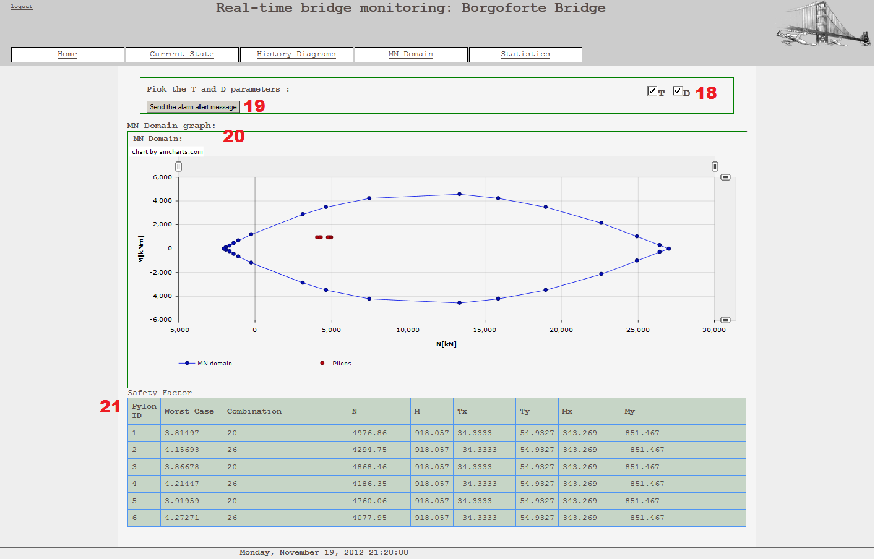
The following picture presents the “MN Domain” page, that is presented when clicking on the MN domain tab (4).
The operator is able to do the following:
- Change the T (traffic) and D (debris) parameters. Changing of these values results in the change of data in the safety factor table (21)
- Click on “Send the alarm alert message (19) will result in a pop-up window which allows the operator to send an alert to the responsible person. The pop-up window is presented below. In order to send the alarm, the operator must click on the “OK” button
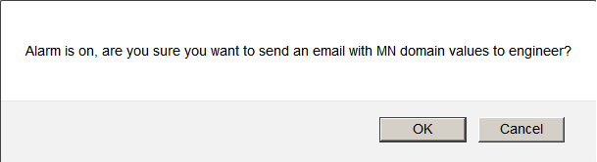
- View the MN domain. All of the pylons are presented with respect to their location in the MN domain, so the operator is able to see whether some of the pylons are in danger
- View the safety factor table, representing the safety factor along with other parameters characteristic for each of the six pylons

2.2.5. View statistics
When the operator clicks on the Statistics tab (6), the following page is presented.
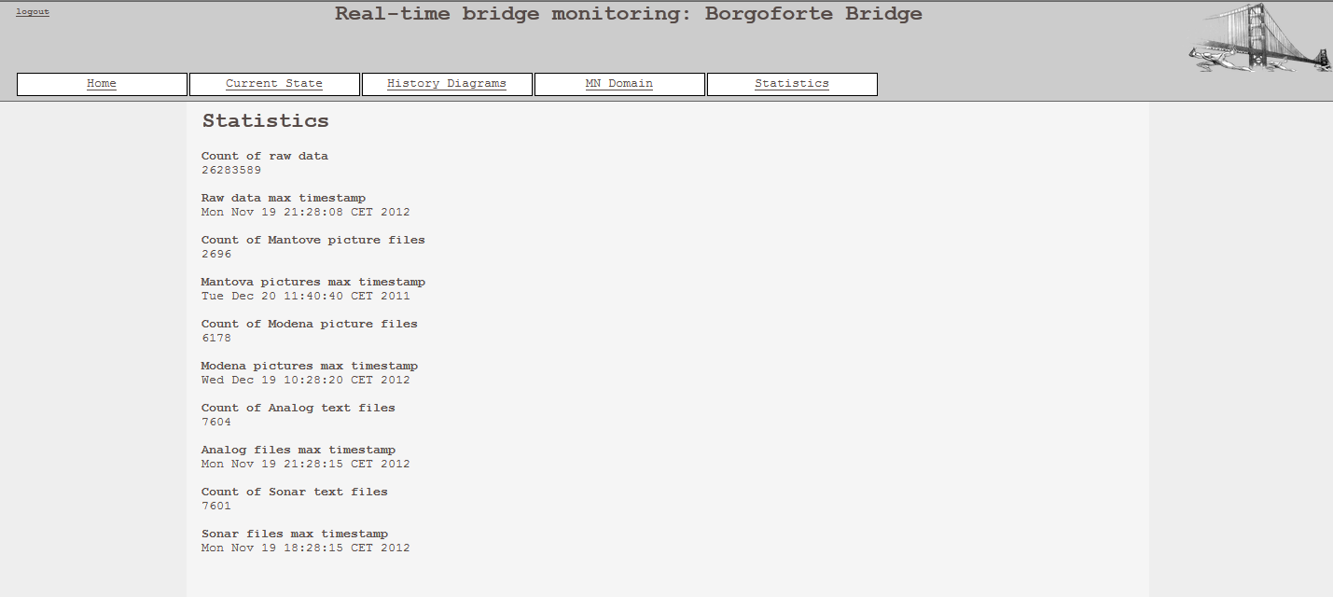
On this page, there is statistical data regarding the parsed files and their values that are located in the database.

2.2.6 Log out
By clicking on the Log-out button (7), the operator is instantly logged out, and becomes an external user with limited privileges.

Engineer
The engineer can access the same functionalities as the operator, and an additional one. When the engineer logs in, he gets an additional tab “Parameters”, which takes him to the parameters site where he can edit the existing parameters from the database.

2.3.1. View and update parameters
When clicking on the “Parameters” tab, the following page is opened.
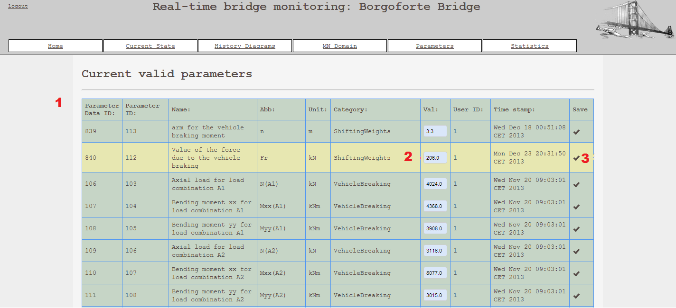
The elements on this page represent the following:
- The engineer can view the table containing information about all the parameters that are present in the database.
- The engineer can change the value of each parameter.
- In order to save the changed value, the engineer clicks on the check-mark (3).

Administrator
If the user logs in as an administrator, then the following page is opened.

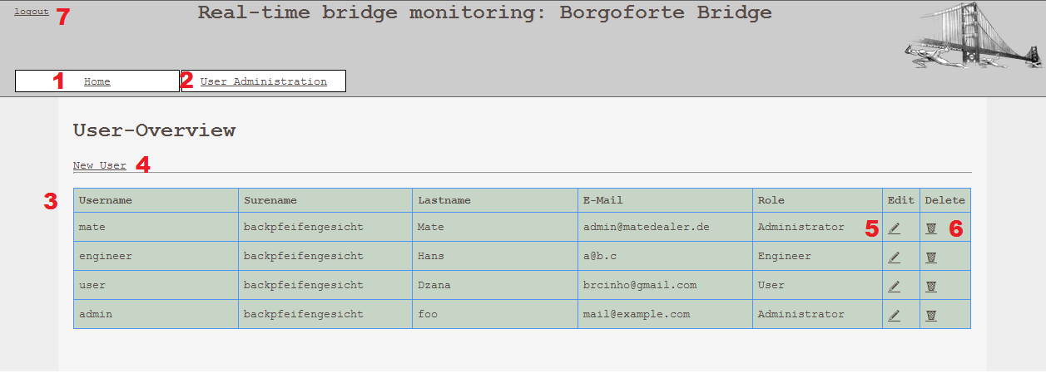
The elements on the page have the following meanings:
- “Home” tab. The home tab for the administrator is the same as for all the other users.
- “User Administration” tab is the default tab that is opened when the administrator logs in, and it is presented in the picture above.
- The table of information about all the users that are registered in the system.
- Link “New User”, which the administrator can click on if he wishes to register a new user in the system. (2.4.1.)
- “Edit” icon, which the administrator can click on if he wishes to edit the specific user. (2.4.2.)
- “Delete” icon, which the administrator can click on if he wishes to delete the specific user.
- “Logout” button, for logging out and becoming an external user with limited privileges.

Add new user
When clicking on link “New User” (4), the following page opens.
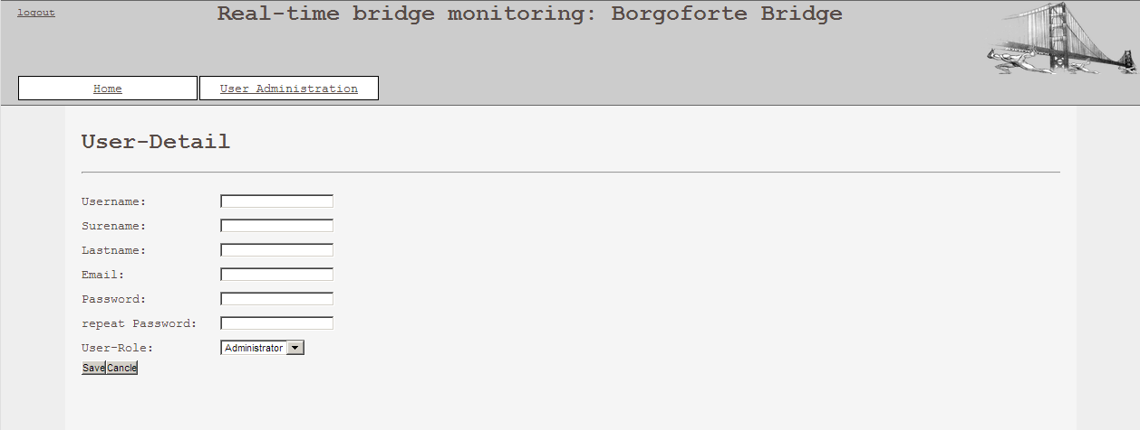
On this page, the administrator can enter the username, surename, last name, email, password, and choose between existing user roles for the new user that he wishes to create. In order to save the entered information and finish the process of creating a new user, the administrator must click on the “Save” button. If he wishes to abort the process, he must click on the “Cancel” button.

Edit user
When clicking on the “Edit user” icon (5), the following page is opened.

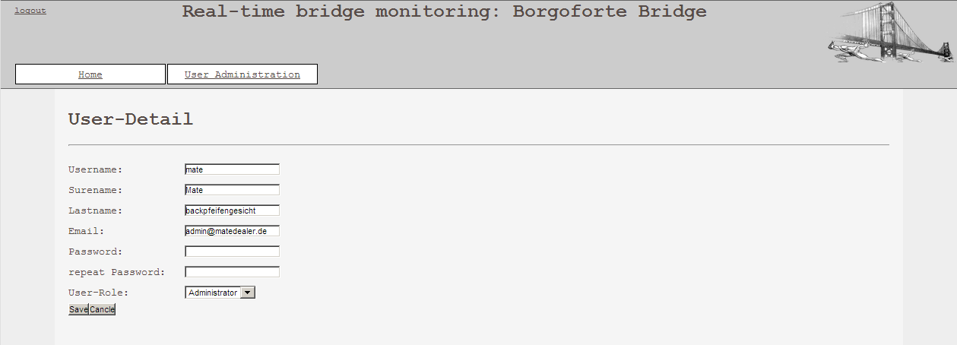
On this page, the administrator can change the user-name, surname, last name, email, password and choose a different user role among the existing ones, for the user that he selected. In order to save the changed information and finish the process of editing the chosen user, the administrator must click on the “Save” button. If he wishes to abort the process, he must click on the “Cancel” button. In this case, the old information about the user will stay unchanged.

